5-1 Discussion: Data Characteristics and Modeling
Michael Surdek posted Jul 6, 2022 8:33 PM

For milestone two I was able to analyze the available data of the GE customer churn use case and its feasibility for a binary classification model that can predict whether or not a customer is likely to cancel their subscription. The original data set is well suited for these purposes as there are few missing values and redundant or useless fields. To prepare the data for further analysis, I simply filtered values that are supposed to be held out for validation and removed the columns CUSTOMER, a unique identifier, and CHURN, a duplicate field that contains target values for the aforementioned validation set.
There are approximately 30 fields that pertain to cellular coverage, equipment, and average usage patterns. The remaining fields include information on each individual such as family makeup, credit rating, occupation, and customer service history. Only 3 fields include categorical values, and the others are numeric, although some of these represent categories and are stored as binary numbers 1 and 0. In fact, 2 of the 3 categorical fields are just labels for those binary variables just mentioned. The third categorical field, CSA, is an alphanumeric geographical code that represents the "Communications Service Area" for each customer.
When I built a simple decision tree to test the design of this classification algorithm, CSA turned out to be the most important variable. However, I am concerned that this is due to values that are too specific and sample sizes that are too small and is therefore overfitting the predictions.
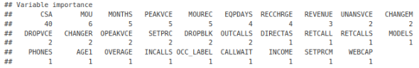
Based on this result, despite my concern, it appears that geographical location plays a large role in customer churn, and that might have to do with the cell service in each area. It will definitely be important to look further into this relationship, and perhaps additional data could be useful for descriptive statistics about the service levels in each area and as inputs to the predictive model. Looking into the CSA field reveals that it contains a general location code, specific location code, and cellular area code. There are at most 20 individuals with the same value, and the ratio of customers who have churned ranges from 20% to 70% in any location.
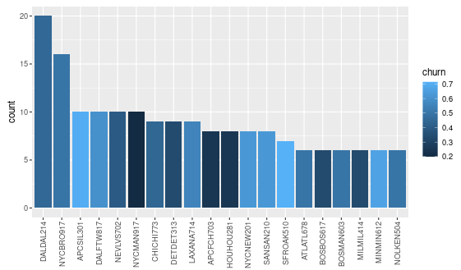
Next, I then ran the same analysis except I grouped the customers by a new variable that only contains the general location code from the CSA field. Most of these larger areas have a ratio of customers who have churned of around 50%, and those that have large or small ratios have relatively few customers.
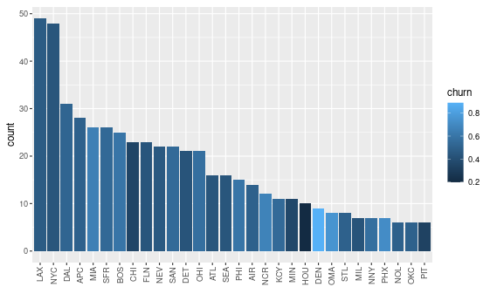
Finally, I wanted to see if there is a relationship between the average service and the percent of customers who have churned in each area. Using the raw number of dropped calls does not show much of a relationship, but using the percent of calls that are dropped shows small signs of a correlation.
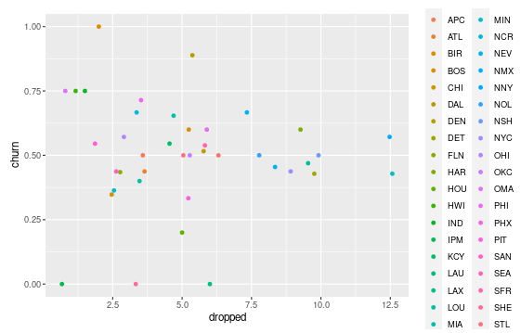
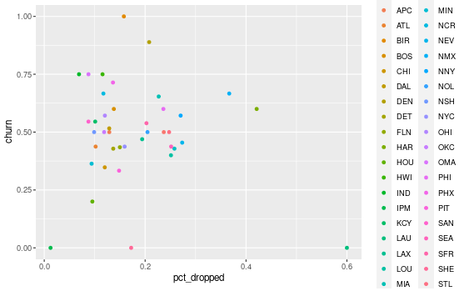
I am still unsure if the communications service area and the additional data that can be derived from it will turn out to be useful in predicting customer churn. It may be too specific or random, but it is possible that using the average service in a customer's area is a better predictor of churn than the service for any customer as an individual.

